Lab 4

4.1 Examine the following code. What is true about the variables and methods within the class NYCustomer?
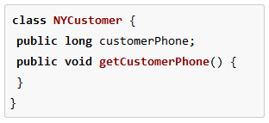
Solution
Because the variable and method is declared in public access modifier it can be called by any code regardless of where the code is located even if it's outside the class

Source code
class NYCustomer():
customerPhone = 1
def getCustomerPhone(self):
NYCustomer.customerPhone = input("Enter Customer Phone Number: ")

def call(self):
print("===============calling from inside the class")
print("The Customer phone number from paraent class is: ", NYCustomer.customerPhone)

class child(NYCustomer):
print("===============calling from inherited class")
rizwan = NYCustomer
rizwan.getCustomerPhone(1)
print("The Customer's Phone Number from child class is: ", rizwan.customerPhone)

class other():
print("===============calling from another the class")
obj = NYCustomer
obj.getCustomerPhone(1)

print("===============calling from outside the class")
nabeel = NYCustomer
print("Customer phone from outside the class is:", nabeel.customerPhone)
nabeel.getCustomerPhone(1)
print("The Customer's Phone NUmber is: ", nabeel.customerPhone)
child()
other()
nabeel.call(1)

Output
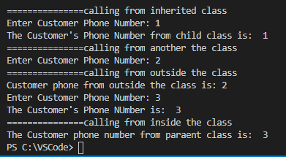

4.2 What is the difference between access and non-access modifiers?

Access modifiers are the keywords which are used with classes, variables, methods, and constructors to control their access level.

Non-access modifiers are those keywords that do not have anything related to the level of access but they provide a special functionality when specified.

4.3 Can you create a subclass to the following class?
classA
{
privateA()
{
//First Constructor
}

privateA(inti)
{
//Second Constructor
}
}
Explain the answer in with reason and justify through python code.
Source code
class A:
def __init__ (self):
print("This is a private constructor 2 of python: ")

def __init__ (self, Number):
self.number = Number
print("This is a private constructor 2 of python: ", self.number)

class student(A):
def __init__(self, cNumber):
A.__init__(self, cNumber)

student(47)

Output
Solution
Yes we can but the inherited subclass will only be able to call the second constructor not the first one.
Reason
Because the above class has a constructor declared in private which can only be used inside this class and nowhere else. So even if we inherit a class from this one it will not be able to access both the constructors present in the parent class.

